Decision Tree
a flowchart or a game of "20 Questions." It's a type of machine learning algorithm that builds a model by learning simple if-then-else rules from a dataset. Its main job is to take a set of inputs and predict a category (or "class"), such as "Yes/No," "Spam/Not Spam," or "Cat/Dog/Fish."

How It Works: The Core Components?
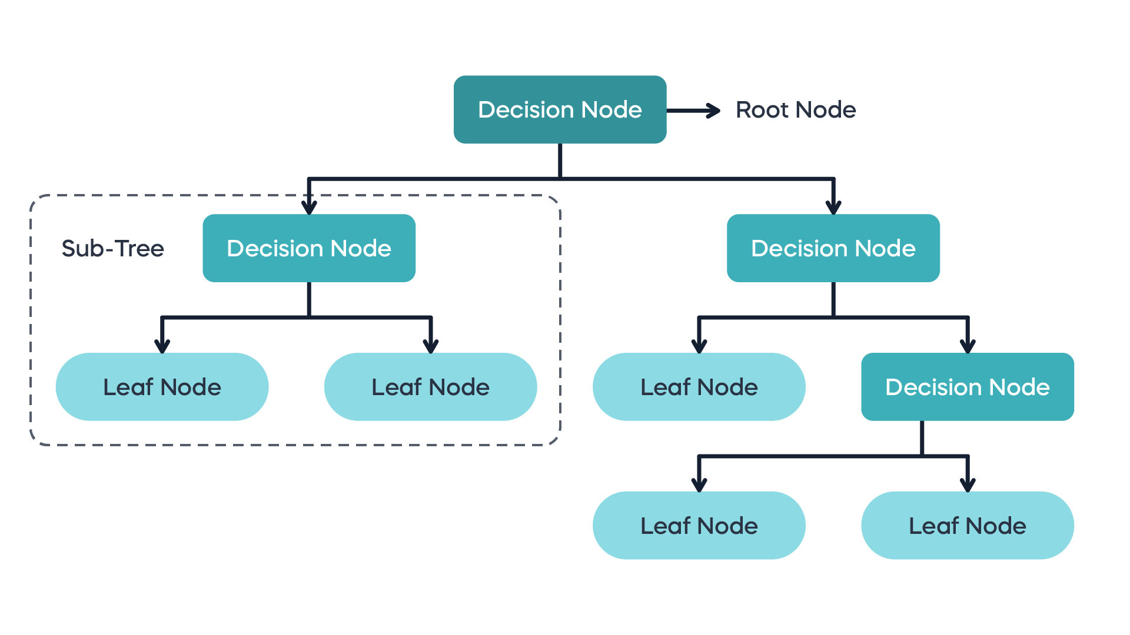

A decision tree has three main types of nodes:
- Root Node: This is the very top of the tree. It represents the entire dataset and is the first "question" the tree asks to start splitting the data.
- Internal Nodes (Decision Nodes): These are the nodes in the middle of the tree. Each one represents a "question" (a test on a specific feature, like "Is Age > 30?"). This node splits the data into two or more sub-groups based on the answer.
- Leaf Nodes (Terminal Nodes): These are the nodes at the very bottom of the tree. They don't ask any more questions. Instead, they represent the final decision or classification (e.g., "Clicked Ad" or "Did Not Click Ad").

How a Tree "Learns": The Splitting Process
A decision tree is built using a process called recursive partitioning. The main goal is to ask the "best" questions first—the ones that do the best job of splitting the data into "pure" groups.
Here's the step-by-step learning process:
- Start at the Root: The algorithm looks at the entire dataset.
- Find the Best Split: It tests every feature (like Age, Income, Is Student?) to find the one question (the best split) that will divide the data into the purest possible child nodes.
- The "Equation" (Measuring Purity): How does it know what the "best" split is? It uses a mathematical formula to measure impurity. The most common formula is the Gini Impurity.
- Make the Split: The algorithm chooses the feature and threshold (e.g., Age > 30) that results in the lowest weighted Gini Impurity for the two new child nodes. This is also called maximizing "Gini Gain."
- Repeat (Recurse): The algorithm now treats each of these child nodes as a new "root node" for the data that fell into it. It repeats steps 2-4, finding the next best question to ask.
- Stop: This process stops when:
  - A node is 100% pure (all members are in one class).
  - The tree reaches a maximum depth set by the user (to prevent it from getting too complex).
  - A split doesn't add any significant value.

Recursive partitioning explain
Recursive partitioning is the core algorithm used to build a decision tree. It's a step-by-step process that repeatedly splits a dataset into smaller and smaller sub-groups
- Start with All Data: The algorithm begins at the root node, which contains the entire dataset.
- Find the Best Split: The algorithm searches through every feature (e.g., Age, Income, Is Student?) to find the single best question to ask that will split the data into two (or more) "purer" sub-groups.
- "Best" means the split creates new groups that are as one-sided as possible (e.g., one group with mostly "Yes" answers and another with mostly "No" answers). It measures this using metrics like Gini Impurity or Entropy.
- A "pure" node is one where all the data belongs to a single class (e.g., a group with 10 "Yes" and 0 "No"). A "impure" node is one with a mixed-up set of classes (e.g., 5 "Yes" and 5 "No")
Name | Gini Impurity. | Entropy
Def | measure the same thing: how "messy" or "impure" a set of data is. | measure the same thing: how "messy" or "impure" a set of data is.
Nickname | "Misclassification" Metric | "Surprise" Metric
Explanation | measures the likelihood of incorrectly classifying a new, random item if you assigned it a label based on the distribution of classes in that node | information theory and measures the amount of disorder, uncertainty  - Scale: 0 to 1.0 (for a two-class problem).  - 0 = Perfect Order: (All data is one class). There is zero surprise. You know exactly what you're going to get.  - 1.0 = Maximum Disorder: (A 50/50 split). This is maximum uncertainty. You are maximally surprised by the outcome because it's a perfect coin flip.
Explanation 2 | A Basket of Fruit 🧺 Imagine you have a basket of 10 fruits.  - Case 1 (Pure): 10 apples 🍎.  - The Gini Impurity is 0. If you randomly pick a fruit, you know it's an apple.  - Case 2 (Impure): 5 apples 🍎 and 5 oranges 🍊.  - The Gini Impurity is 0.5. This is maximum chaos. If you randomly pick a fruit, you have a 50% chance of guessing wrong. | The Same Fruit Basket 🧺  - Case 1 (Pure): 10 apples 🍎.  - The Entropy is 0. There is no uncertainty or surprise.  - Case 2 (Impure): 5 apples 🍎 and 5 oranges 🍊.  - The Entropy is 1.0. This is maximum disorder and surprise.
Sol | Case 3 (Better): 8 apples 🍎 and 2 oranges 🍊.  - The Gini Impurity is 0.32. It's still impure, but much "cleaner" than Case 2 | - Case 3 (Better): 8 apples 🍎 and 2 oranges 🍊.  - The Entropy is 0.72. There is some disorder, but much less than in Case 2.
What it measures | Probability of misclassification | Amount of disorder/uncertainty
Calculation | 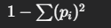 | 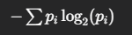
Computation | Faster. It only involves squaring | Slightly slower. It involves a logarithm.
Result | Tends to favor larger partitions. | Tends to create slightly more balanced trees.

- Partition the Data: The algorithm makes the split, creating new "branches" that lead to new "child nodes." Each child node holds the subset of data that answered the question in a specific way.
- RECURSE: This is the key. The algorithm now treats each of these child nodes as a new, smaller dataset and repeats the entire process from Step 2. It finds the next best question to ask for that sub-group.
- Stop: This process stops for any given branch when:
- A node is 100% "pure" (all data points in it belong to the same class).
- It reaches a pre-set limit (like a maximum "depth" or a minimum number of samples in a node).
- No further split can make the groups significantly purer.

kind of decision tree
There are two main kinds of decision trees, based on what type of value they are trying to predict.
1. Classification Trees
This is the type you just asked about. Its goal is to predict a discrete category or class.
- Output: A class label (e.g., "Yes," "No," "Spam," "Not Spam," "Cat," "Dog").
- How it Works: It splits the data based on questions that best separate the classes. The final "answer" in a leaf node is determined by a majority vote.
- Example: If a leaf node contains 8 samples that are "Spam" and 2 samples that are "Not Spam," the tree will predict "Spam" for any new data point that lands in that leaf.
2. Regression Trees
This type is used when your goal is to predict a continuous numerical value.
- Output: A number (e.g., $150,000, 75.3 degrees, 4.5 years).
- How it Works: It splits the data based on questions that minimize the variance of the numbers in the resulting groups. The final "answer" in a leaf node is the average (or mean) of all the training samples that landed there.
- Example: You want to predict a house price. A leaf node might end up with 3 houses from your training data.
  - House 1 Price: $200,000
  - House 2 Price: $210,000
  - House 3 Price: $190,000
  - The tree's prediction for any new house that lands in this leaf will be the average: $200,000.

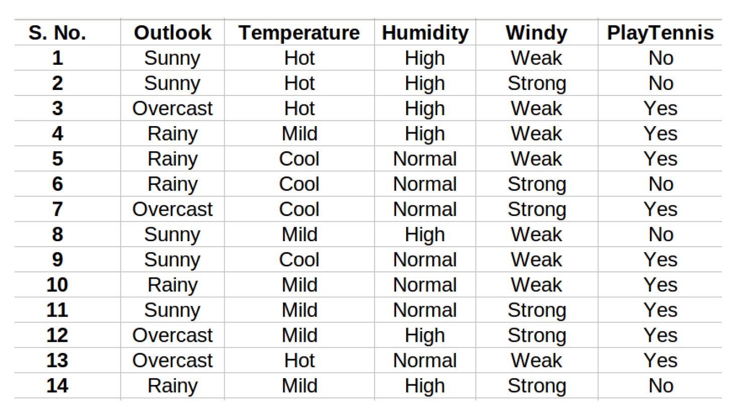
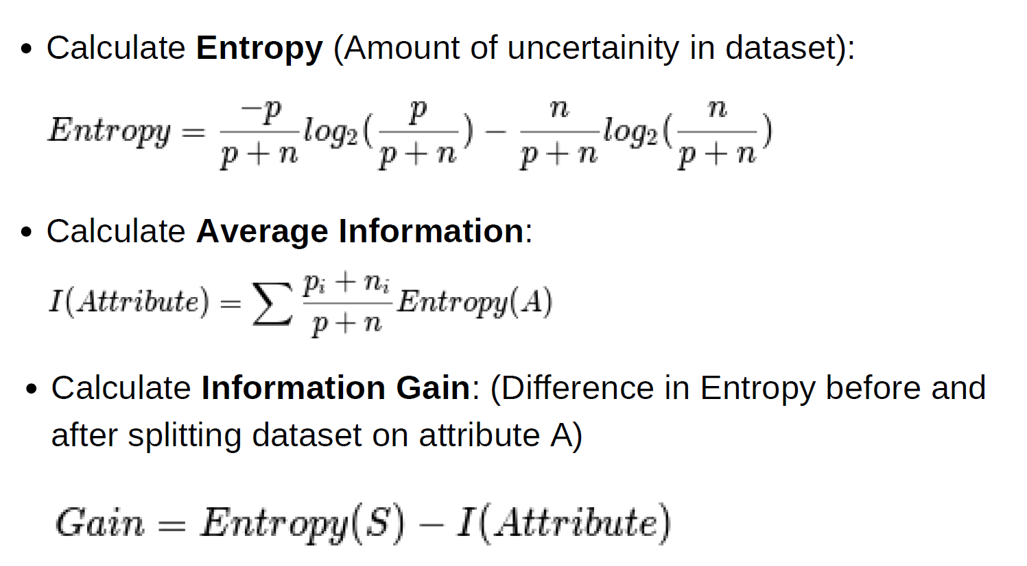

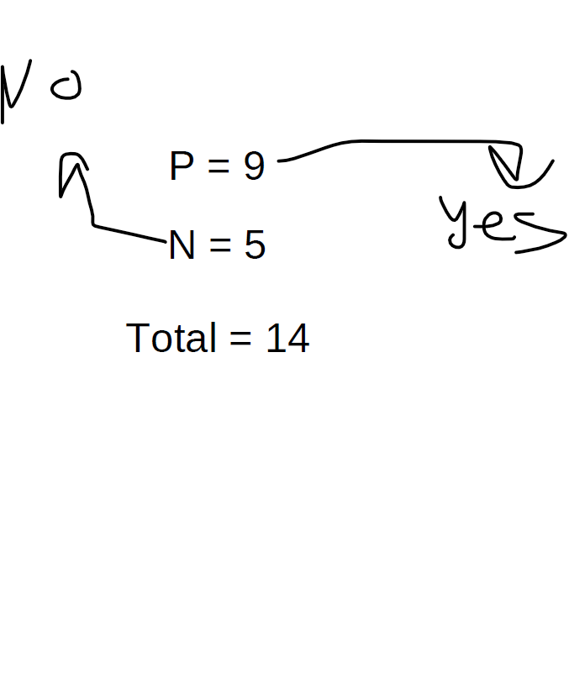
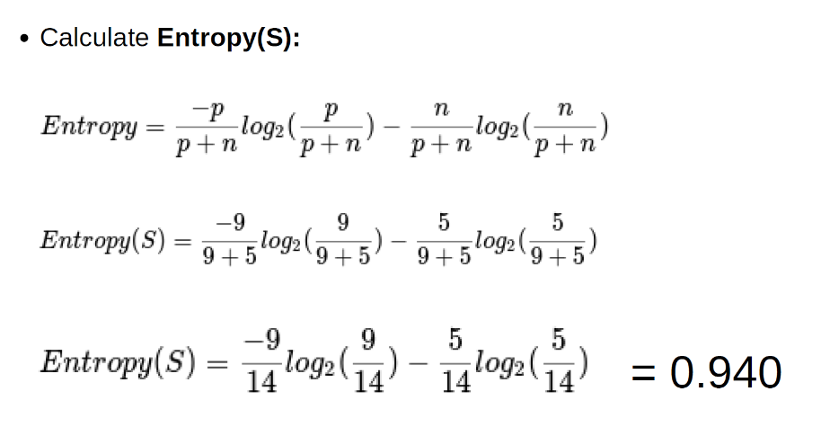

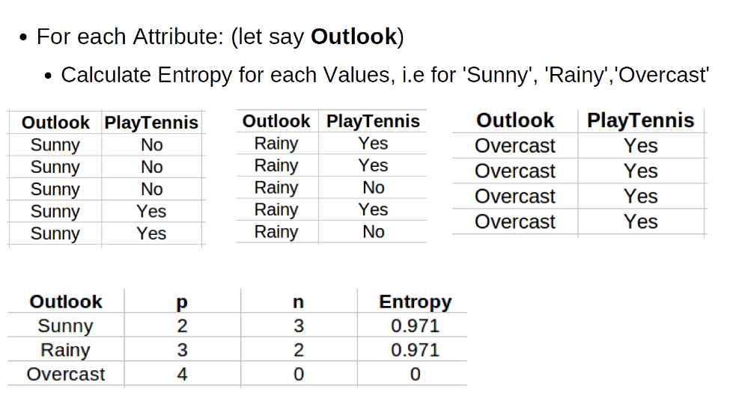
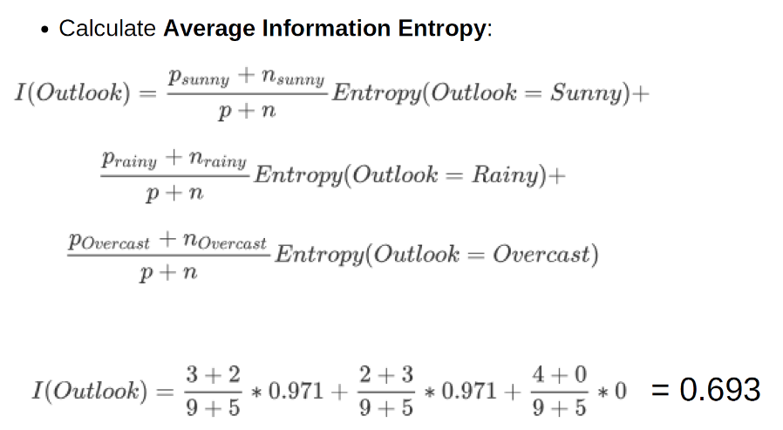
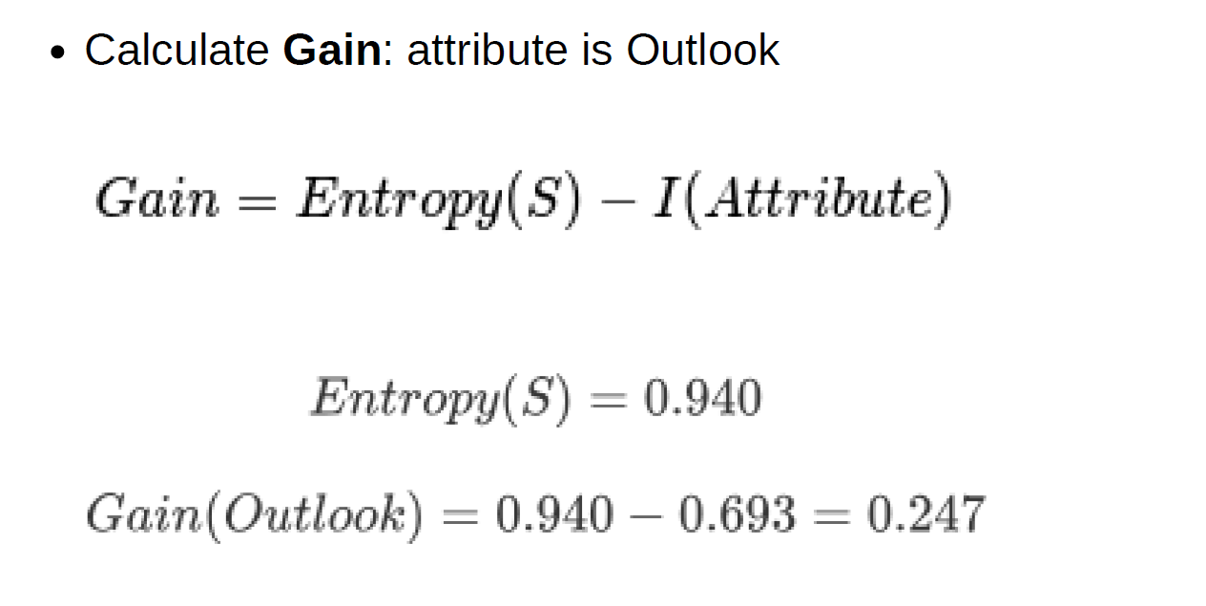
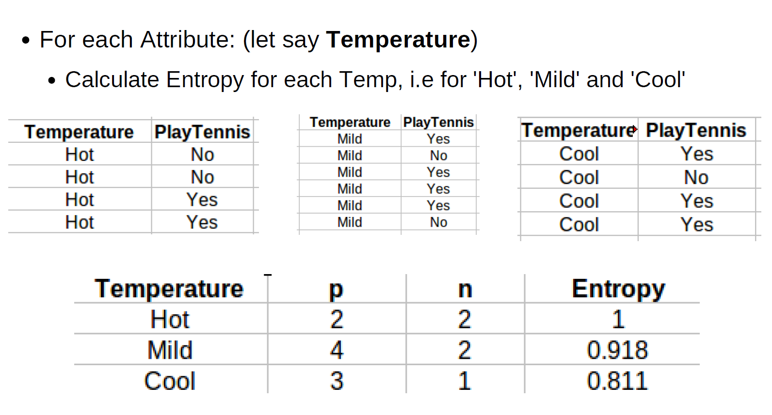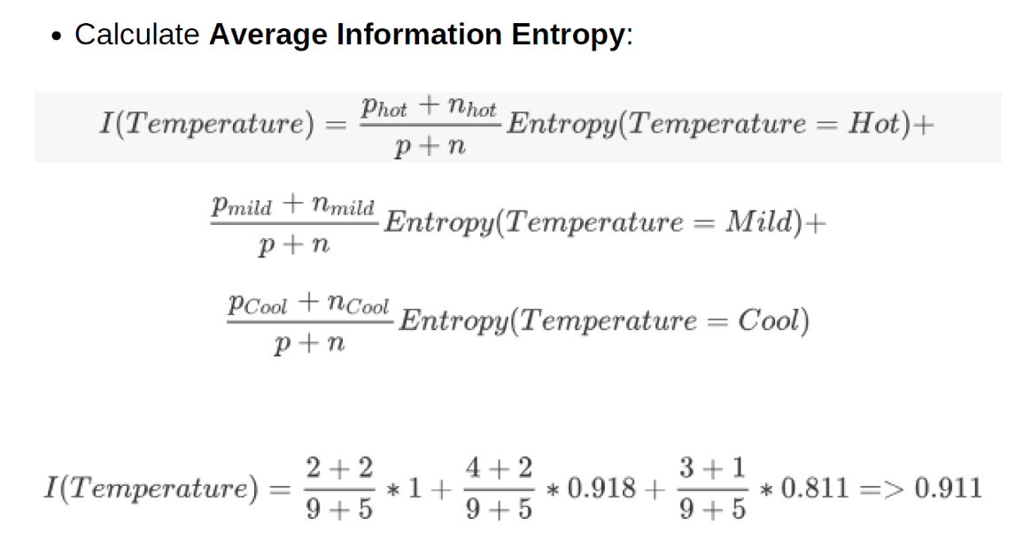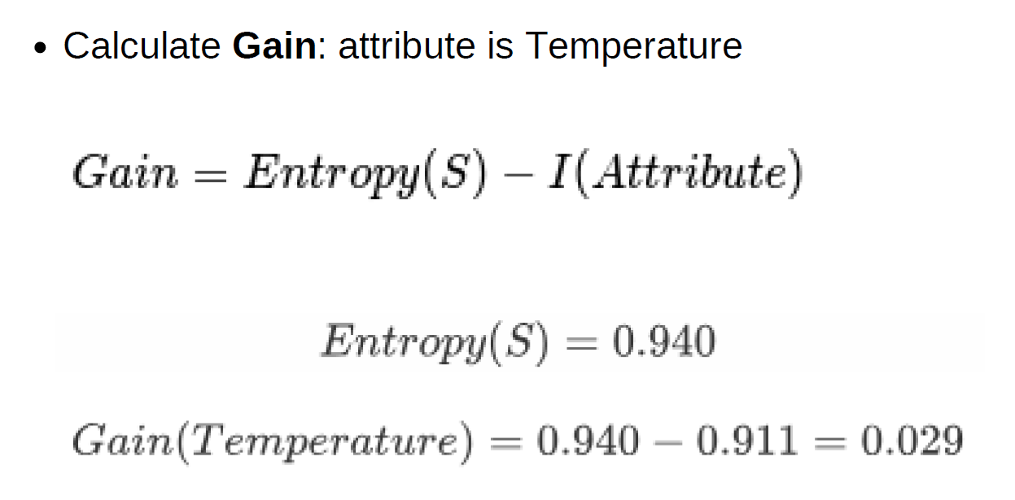
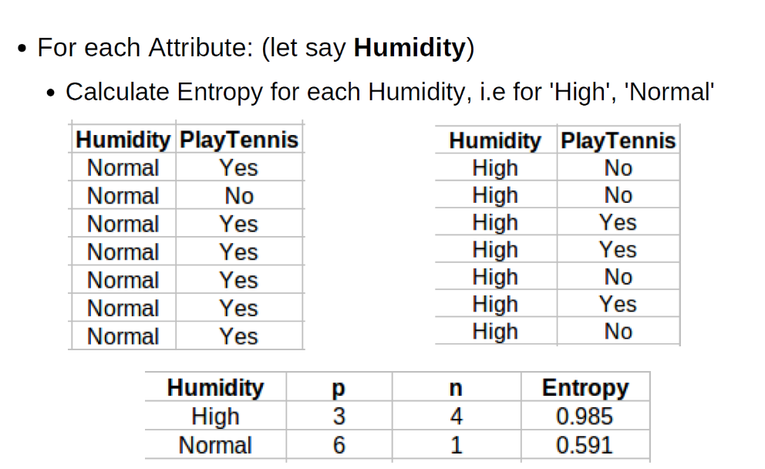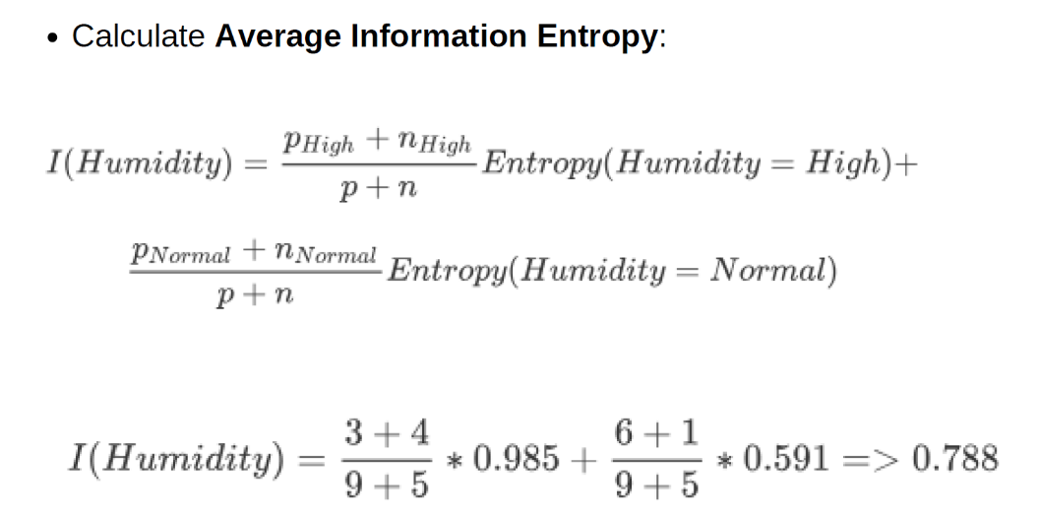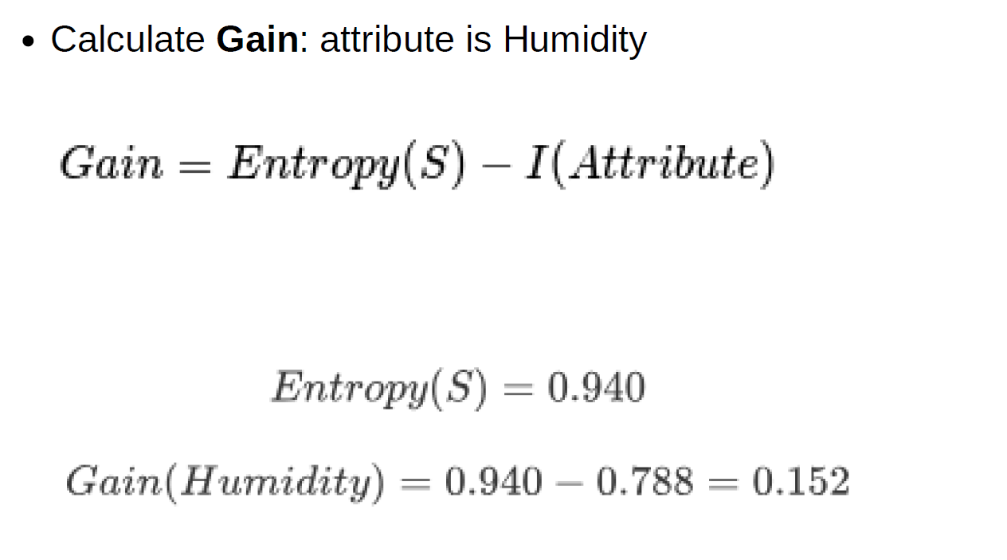
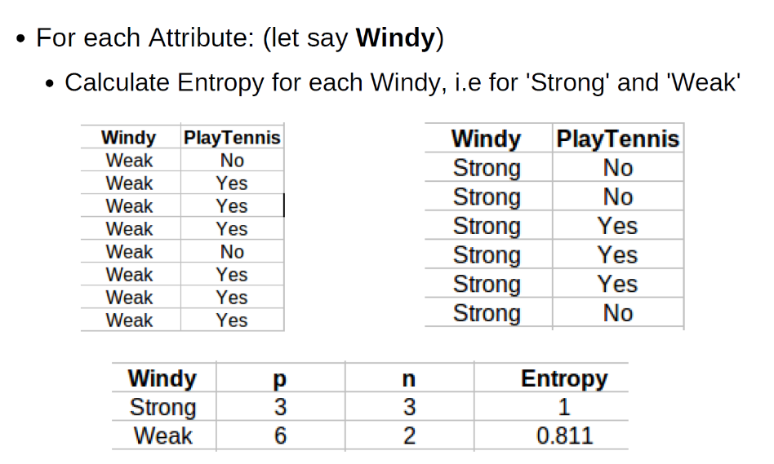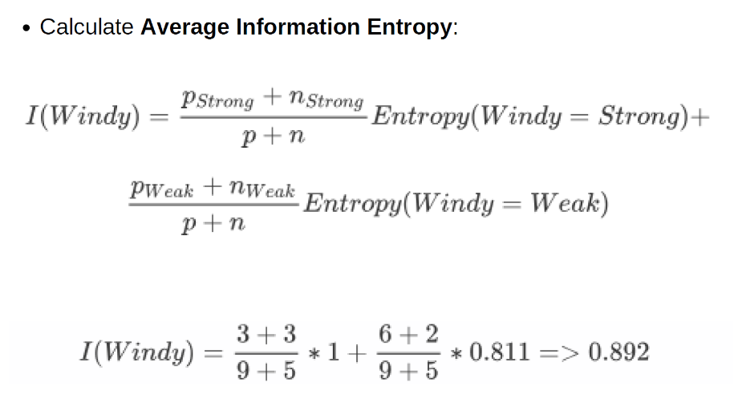
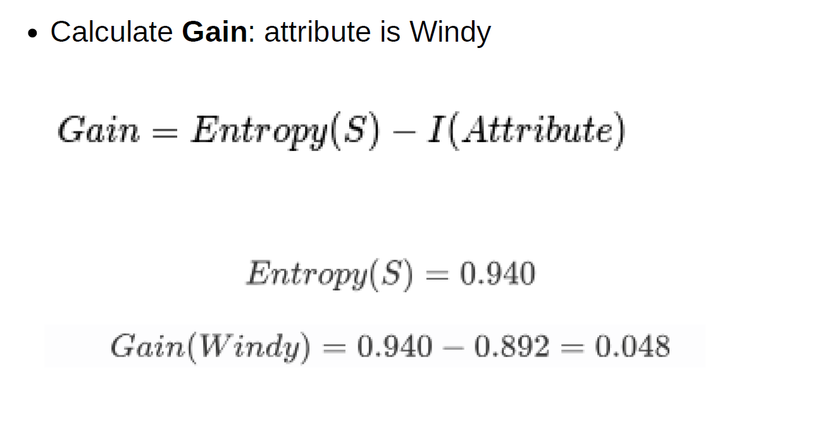
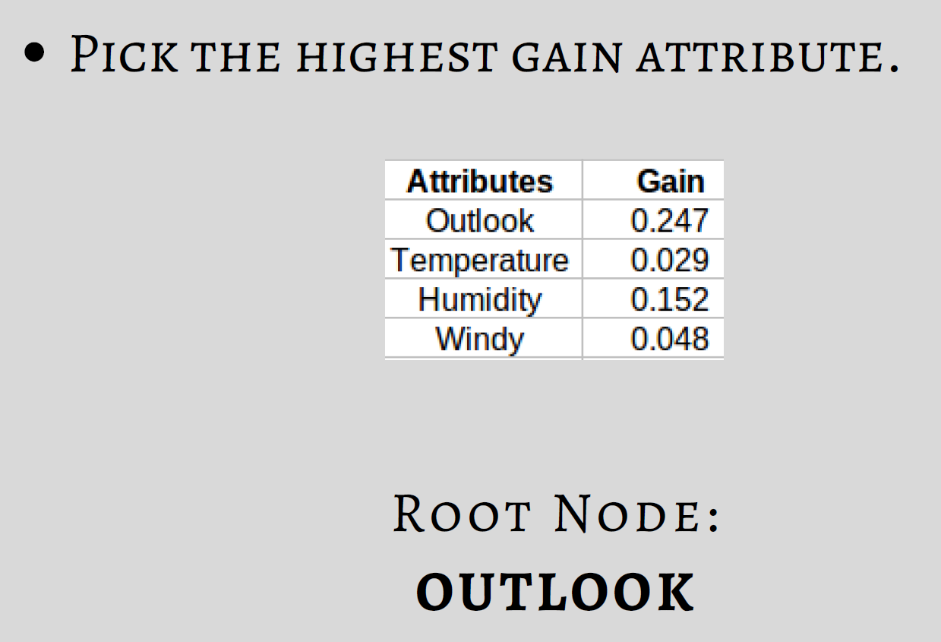
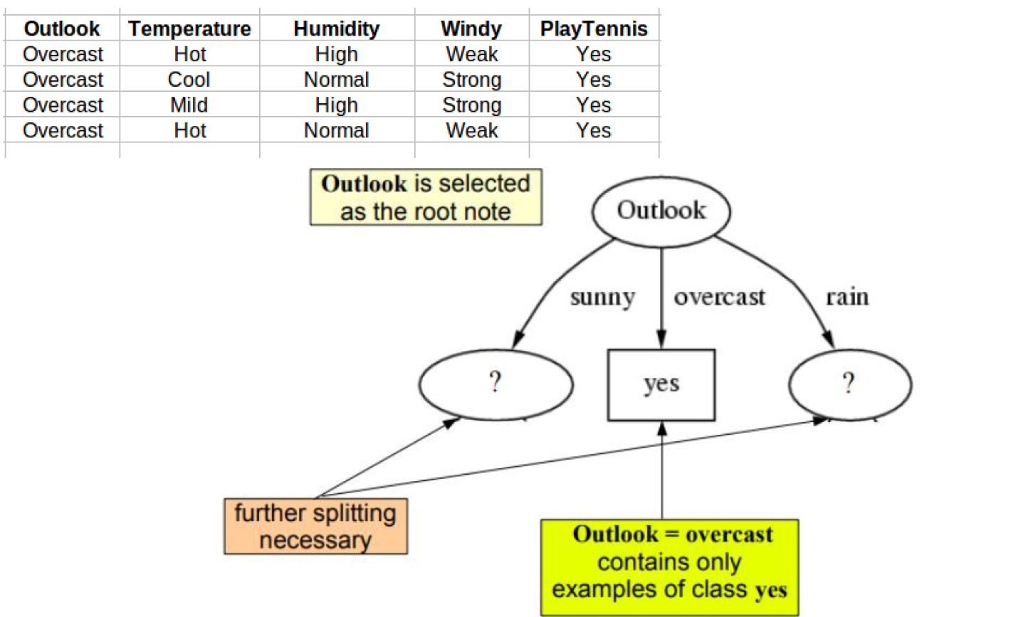

- Repeat the same thing for sub-trees till we get the tree.
- Calculate Entropy for each Humidity, i.e for 'High' and 'Normal'
- Calculate Average Information Entropy: I(Humidity) = 0
- Calculate Gain: Gain = 0.971
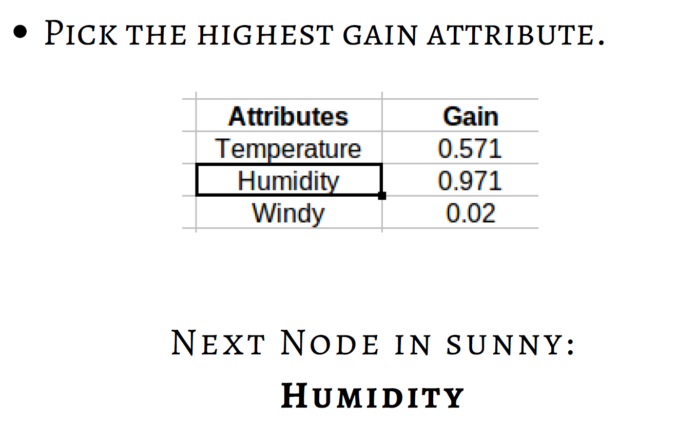
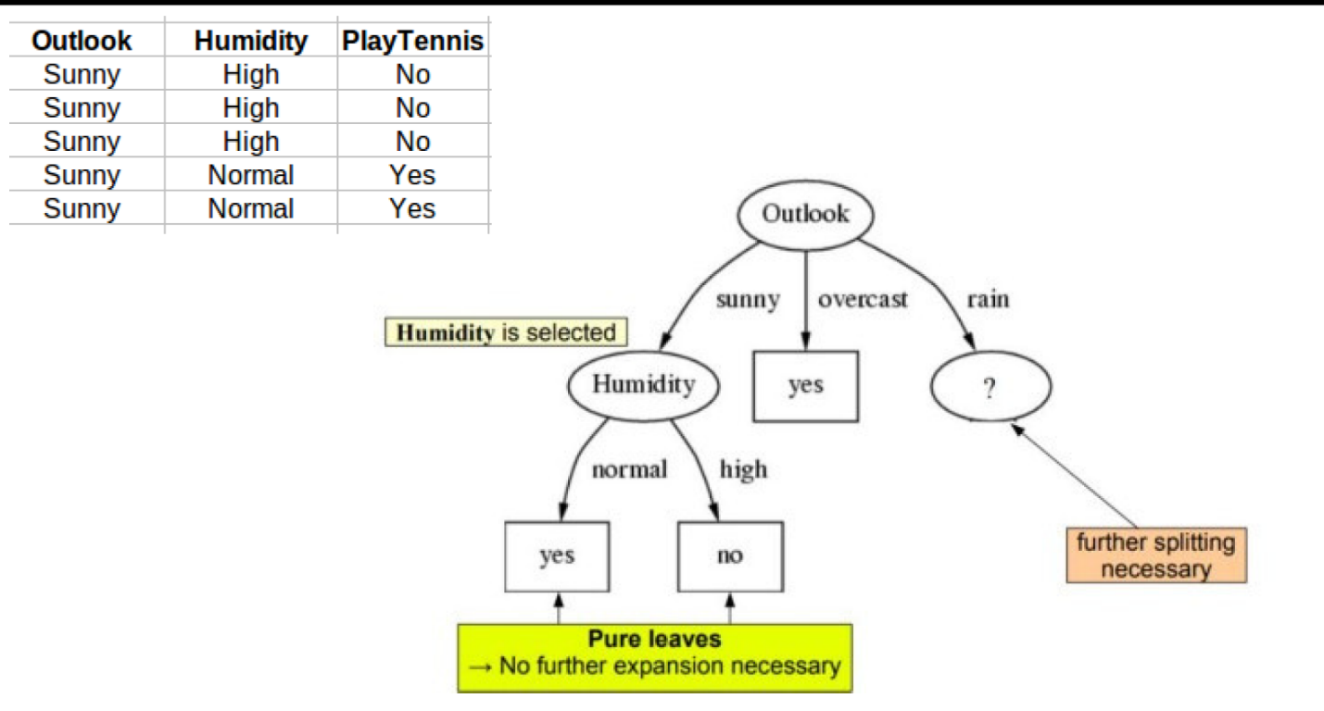
- Repeat the same thing for sub-trees till we get the tree.
- Calculate Entropy for each windy,
- Calculate Average Information Entropy:
- Calculate Gain: Gain .
